11.90: Solving Eq. (11.14) for 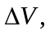
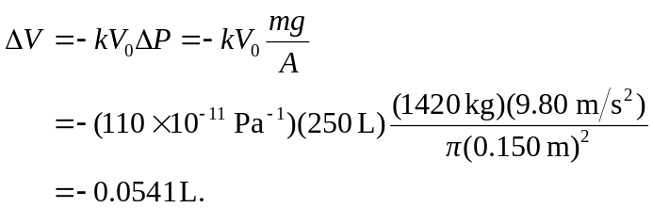

The minus sign indicates that this is the volume by which the original hooch has shrunk, and is the extra volume that can be stored.

